Project Titan-TDD-INT097_CCH_Timesheet_Management_Dashboard

“Timesheet Management System”

|  |  |
| --- | --- |
| **Author** | Nimesh Rastogi |
| **Creation Date** | 10-09-2024 |
| **Last Updated** | 11-09-2024 |
| **Client** | CROSS COUNTRY HEALTHCARE |
| **Document Version** | 1.0 |
| **Document Ref** | <Document Reference Number> |
| **Draft** | 1A |

Document Control Information

Document Information

|  |  |
| --- | --- |
| Document Identification |  |
| Document Name | **Project Titan-TDD-INT097_CCH_Timesheet_Management_Dashboard** |
| Project Name | **Project Titan** |
| Client | **Cross Country Health, Inc.** |
| Document Author | Nimesh Rastogi |
| Document Version | 1.0 |
| Document Status |  |
| Date Released |  |

Document Edit History

| Version | Date | Additions/Modifications | Prepared/Revised by |
| --- | --- | --- | --- |
| 1.0 | 10-09-2024 | Initial Version | Nimesh Rastogi |

Document Review/Approval History

| Date | Name | Organization/Title | Comments |
| --- | --- | --- | --- |
| 11-09-2023 | Nikhil Khairnar | Capgemini |  |

Table of Contents

1. Overview 4

1.1 Technical Overview 4

1.2 Objective 4

1.3 Assumptions 4

2. Dependencies and Prerequisites 5

3. Definitions & Abbreviations 6

4. Technical Specifications 7

4.1 Technical Overview 7

4.2 In Scope 7

4.3 Out of Scope 7

4.4 Approach 7

4.5 Technical Flow Diagram 8

4.6 Mass Time Entry Flow Diagram 8

4.7 Technical / Interface Architecture 9

4.8 Technical Flow Description 9

5. Mass Time Entry Layout Snapshot 10

5.1. Timesheet 10

5.2. Exception Management tool 14

5.3. Sub-screen to enter break in/out 18

5.4 Timesheet Attachment 20

5.5 Time Entry Element 23

5.5 Technical components list 25

5.6 References 26

➢ Open and Closed Issues 27

Open Issues 27

Closed Issues 27

Attachments 28

# Overview

## Technical Overview

This document captures the detailed design for “Timesheet Management System.” It also provides the technical development team with key information on assumptions, rules, and high-level flow logic that are required to develop the technical component.

## Objective

This document forms the basis for the detailed technical design for the “**Timesheet Management System.**” The Timesheet Management System on VBCS screen (PaaS) allows time administrator to add/update/delete the timecards coming from different third-party timecard systems of CCH before entering Oracle (SaaS).

CCH Timesheet Screen facilitates the visualization of data that can be edited which is coming from different third-party timecard systems of CCH to the ATP database.

This technical specification document will also provide the technical development team with key information on assumptions, rules, and high-level functional flow logic that are required to develop the technical components of this CCH Timesheet.

## Assumptions

* All tables, data fields would be identified and correctly stored in ATP Database.

# Dependencies and Prerequisites

* ATP Database
* Data should be available

# Definitions & Abbreviations

Mention Abbreviations and their meaning in below table

| Abbreviation/Term | Meaning/Definition |
| --- | --- |
| VBCS | Oracle Visual Builder Cloud Service |
| OIC | Oracle Integration Cloud |
| CCH | [Cross Country Healthcare](https://www.crosscountry.com/) |
| REST | Representational State Transfer  <https://en.wikipedia.org/wiki/Representational_state_transfer> |
| ATP | Autonomous Transaction Processing |

# Technical Specifications

This document defines the technical details required to implement the **(“Timesheet Management System”).** This document should be considered as the complete detailed screen design for **“Timesheet Management System.”**

## 4.1 Technical Overview

This timesheet data coming from different third-party timecard systems of CCH and further storing in ATP database. The data fetched from Oracle ATP (Autonomous Transaction Processing). It involves the details of table data for timesheet entry.

## 4.2 In Scope

Bring Data from ATP (Autonomous Transaction Processing) to Oracle VBCS(PaaS).

## 4.3 Out of Scope

N/A

## 4.4 Approach

* The timecards data coming from different third-party systems of CCH will be stored in ATP Database.
* Creation of Oracle ATP Database connection.
* For data fetching data we need to use VBCS Tenant Database.
* Using rest call data will be populated in (VBCS) CCH Timesheet screen.
* Person Number, Assignment Number, Name, Element, Date, In Time, Out Time, Duration, UOM, Quantity, Facility Additional Info(hyperlink), Site all these columns will be added to table.
* The search facility created to search the data by creating fields Customer, Account, Site, Week Ending.
* Search button and event created to search the data and show respective result.
* Reset button and event created for reset all values back to default state.
* Delete button and event created to delete selected row line details.
* Add Row button and event created to add new row in table.
* Edit facility and events are created to edit the data for corrections of mass time entry.
* Save button and event created to save the changes, corrections done in time entry.
* Can be able to update Meal Break for each person by clicking on menu button’s
* Then data will be transferred to Oracle OTL (SaaS) and respective rules are fired to transfer the timesheet data.

## 4.5 Technical Flow Diagram

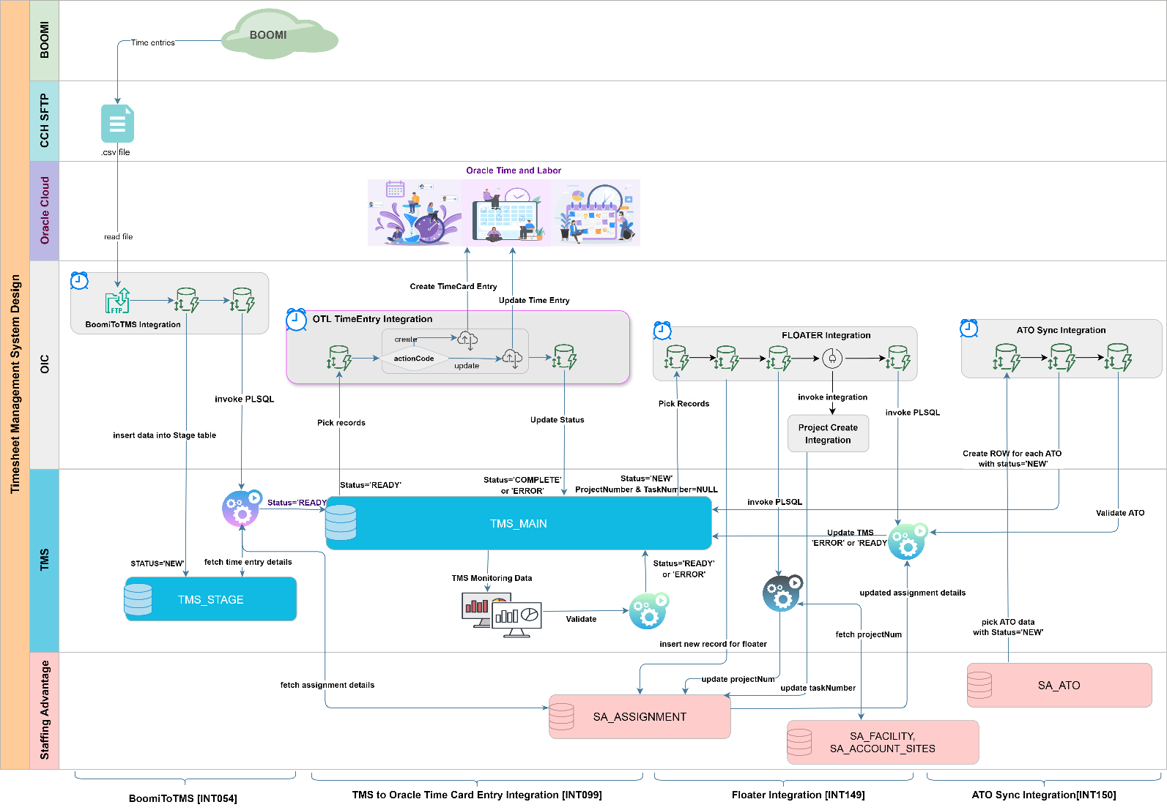

## 4.6 Mass Time Entry Flow Diagram

## 4.7 Technical / Interface Architecture

Same as technical flow diagram

## 4.8 Technical Flow Description

* From third party system Boomi will bring all data to OIC and via OIC the timecards data of CCH will be maintained in ATP Database.
* The tables are already created in Oracle ATP database.
* The data is loaded from ATP database to Oracle VBCS (PaaS) using rest services.
* The data is shown on VBCS screen of Mass Time Entry can be edited or updated and stored again on ATP database.
* Using OIC the data transferred to the Oracle OTL (SaaS) and rules are applied.

# Mass Time Entry Layout Snapshot

## 5.1. Timesheet

Main screen **CCH Timesheet Management System** dashboard as shown below:

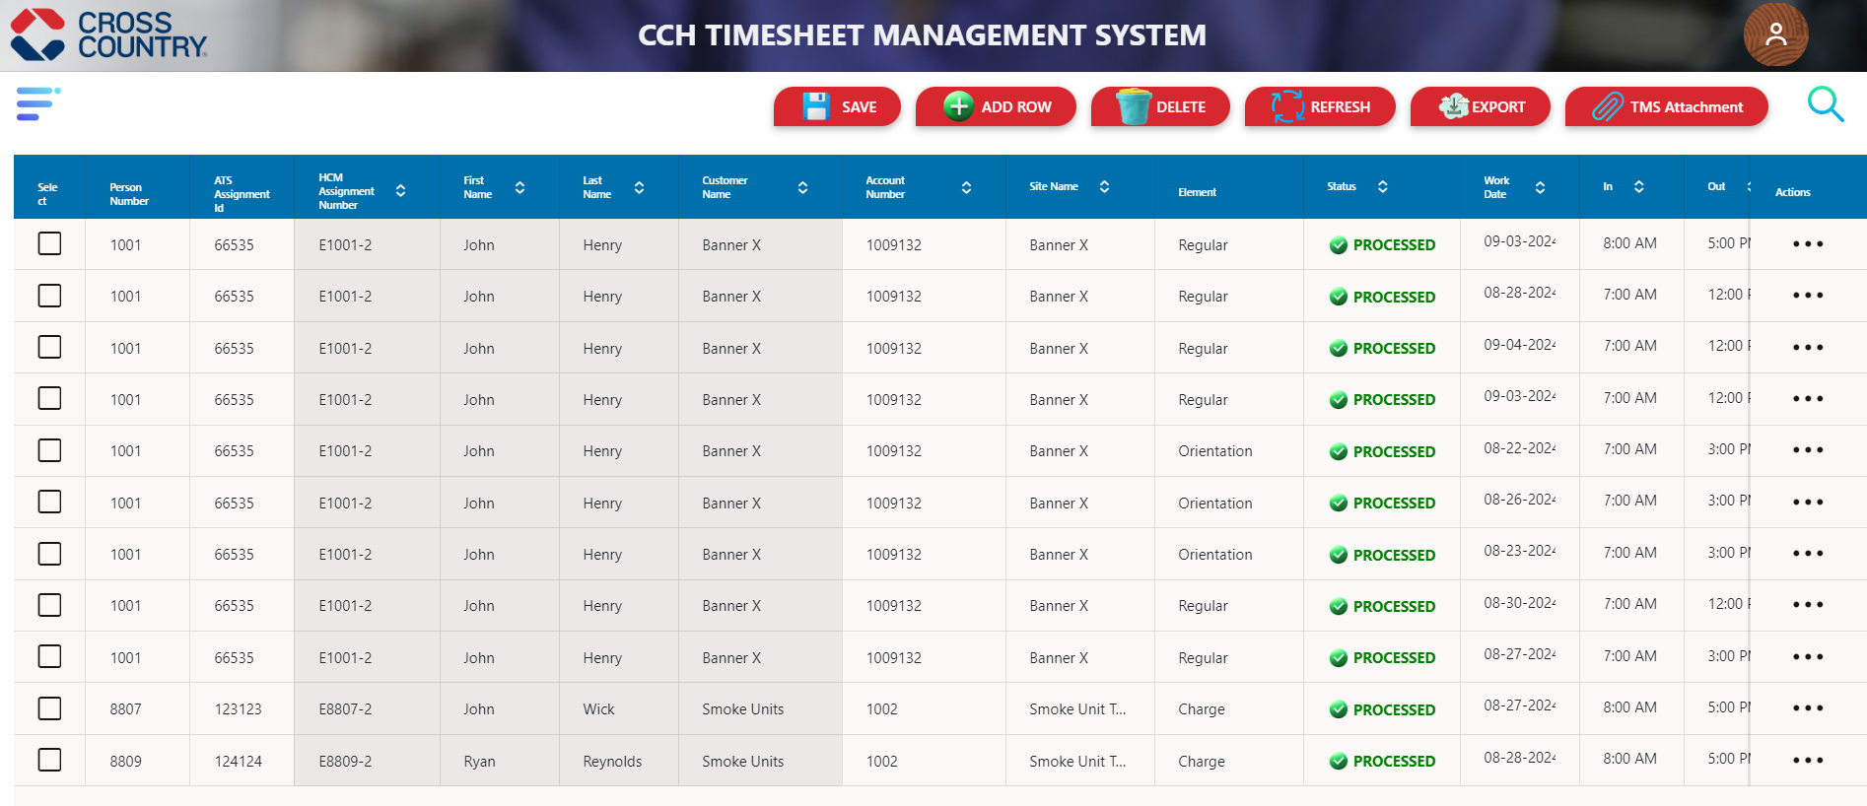

* The data is queried from the ATP database, specifically from the **TMS_MAIN table**, which retrieves timesheet records and renders the details on the Timesheet management system interface.
* The TMS screen is configured to display only data with statuses of "**READY**" and **“PROCESSED**", excluding all other status entries.
* TMS interface will display Person number, Ats Assignment Id, HCM Assignment Number, First name, Last name, Customer Name, Account Number, Site Name, Element., Status, Work Date, In Time, Out Time, Duration, Meal Break, Project ID, Task ID, UOM, Quantity, VMS System, Action.
* Each column is equipped with a sorting algorithm that enables data to be dynamically ordered in ascending or descending sequence, as required within the dashboard interface.
* As illustrated in the diagram above, the system offers a range of features, including Save, Add Row, Delete, Refresh, Export, TMS Attachment, and Search functionalities, each designed to enhance user interaction by providing comprehensive data management.

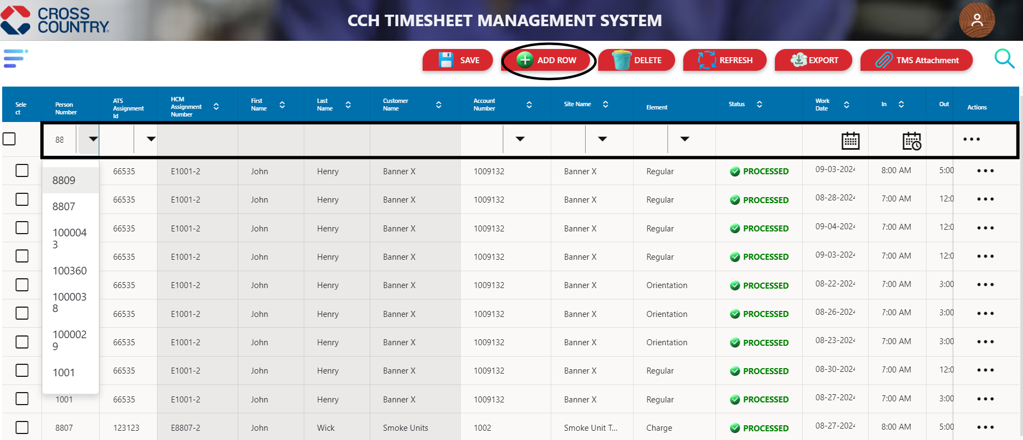

* **ADD ROW** Functionality: Users can add a new row to the timesheet by clicking the "Add Row" button, which dynamically inserts a blank entry into the data grid.

* Upon selecting a Person Number and ATS Assignment ID from the List of Values (LOV) within the newly added row, HCM Assignment Number, First Name, Last Name, Customer Name, Account Number, Site Name relevant fields are auto populated with data fetched based on the selected Person ID, streamlining data entry and reducing manual input errors and it will sync all Customer Account and sites from Oracle into TMS.
* For remaining fields, allowing for complete and accurate data entry as required.

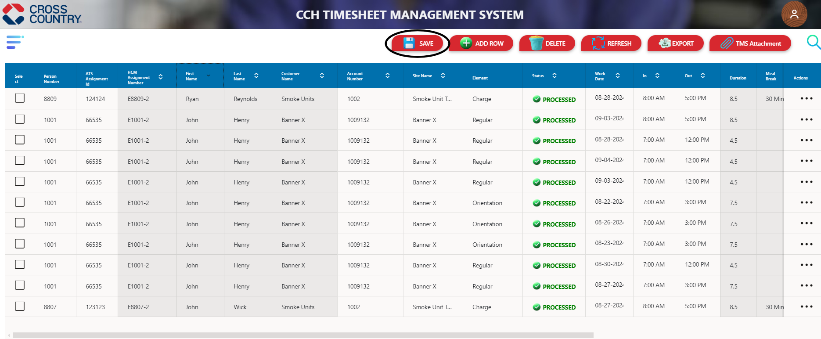

* **SAVE** Functionality: After all required fields in the newly added row are filled, the user can click the "Save" button to commit the changes, ensuring the new entry is appended to the existing dataset.
* Upon saving, the system synchronizes the data with the database, and the updated information is instantly reflected on the interface, providing visibility of the new line item on the TMS screen.

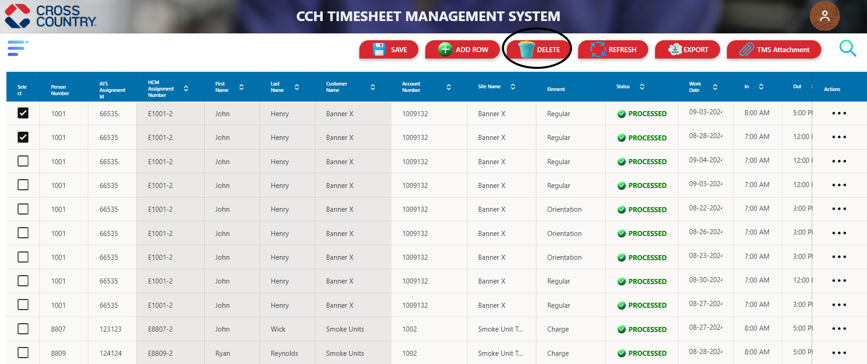

* **DELETE**- Each row includes a checkbox that allows users to select specific entries for deletion, selecting the checkbox marks the row for removal.
* After selecting the desired row(s), clicking the "**DELETE**" button triggers the removal process, deleting the selected row(s) from the dashboard and updating the TMS interface accordingly.

* **REFRESH**: A reset feature is available that allows users to revert all values back to their default state, clearing any unsaved changes and restoring the TMS original data view by click on REFRESH button.
* **EXPORT**: An export-to-Excel functionality is implemented, enabling users to extract the current dataset of TMS and download it in Excel format by clicking the "EXPORT" button, facilitating easy offline analysis and reporting.

* **SEARCH**: - By clicking the **search icon**, users access a dedicated search window where they can input search parameters to filter and retrieve relevant data from the system.
* The TMS includes a search feature that allows users to filter data based on multiple criteria, including Customer, Account, Person Number, Status, Week Starting, Payroll Administrator.

## 5.2. Exception Management tool

* **Navigation to Exception Screen**: To access the Exception Screen, click the menu icon, select the "Exception" option from the menu, which then navigates you directly to the Exception Screen.

* Main screen **Exception Management Interface** as shown below:

* Data is extracted from the ATP database, targeting the **TMS_MAIN** table, which retrieves timesheet records and displays the details within Exception screen interface.
* The Exception Management Interface screen is configured to display only data with statuses of "**ERROR**" along with provide error message with it.
* Exception screen interface will display Person number, Ats Assignment Id, HCM Assignment Number, First name, Last name, Customer Name, Account Number, Site Name, Element., Status, Error Details, Work Date, In Time, Out Time, Duration, Meal Break, Project ID, Task ID, UOM, Quantity, VMS System, Action.
* Each column features a sorting mechanism that allows users to dynamically arrange data in either ascending or descending order, depending on their needs, within exception interface.
* The diagram above displays various system features such as Save, Delete, Archive, Refresh, Export, and Search, to optimize user interaction and facilitate comprehensive data management.
* To edit a record, select the appropriate Person ID and Assignment ID. Upon entering the correct data and saving the changes, the record status will be updated to "Ready" and will subsequently be processed for display on the TMS main screen.

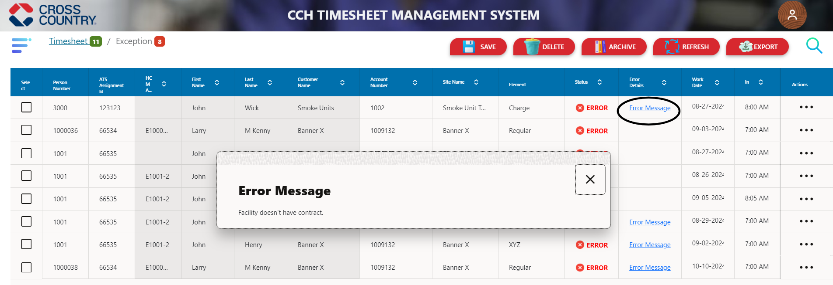

* An **Error Message** hyperlink is available for each row in the ERROR Details column; clicking this link opens a window displaying the specific error message, which details the cause of the encountered issue for the respected row on TMS screen.

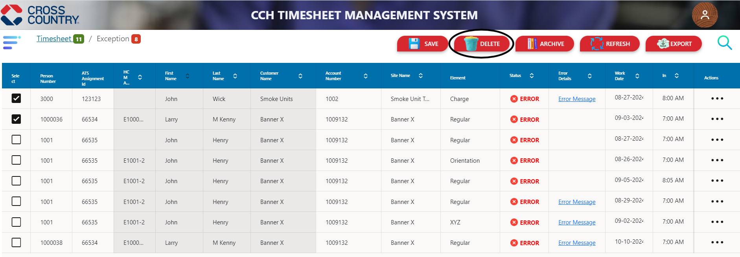

* **DELETE**: Each row features a checkbox enabling users to select entries for deletion. Marking the checkbox indicates that the row is flagged for removal.
* Once the desired row(s) are selected, clicking the "DELETE" button initiates the deletion process, removing the selected rows from the dashboard and refreshing the Exception screen to reflect these changes.

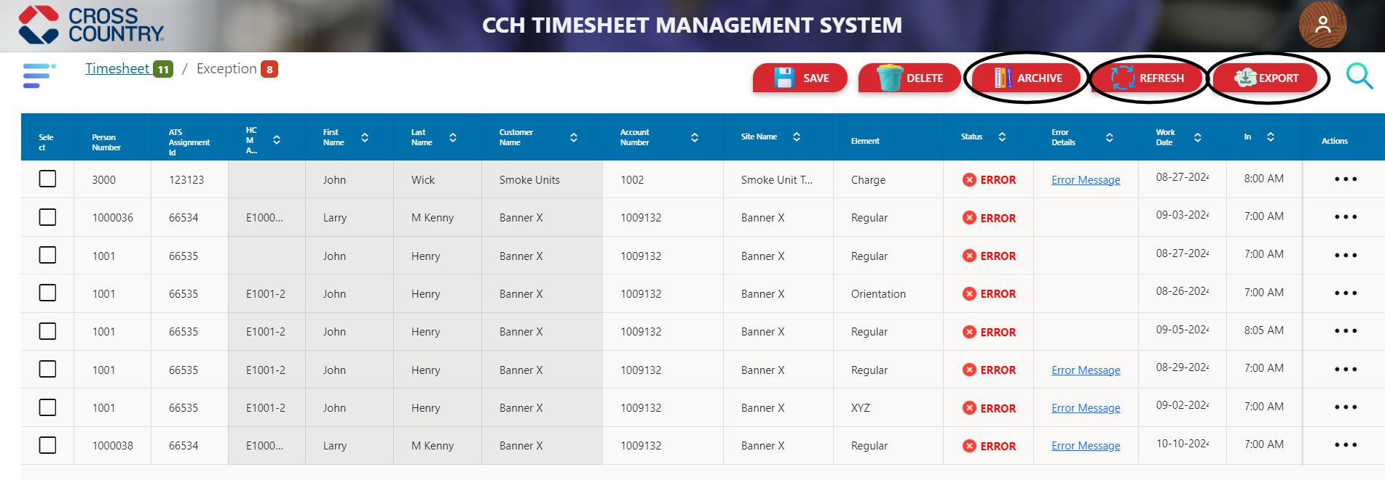

* **ARCHIVE**: The archive functionality allows users to select and move specific rows from the active data table to an archived state, removing them from the current view. This process preserves the data for historical or reference purposes without cluttering the main interface.
* Select the rows intended for archiving and click the "**Archive**" button to initiate the process.
* The selected rows are then archived, causing them to be removed from the active table view while retaining the data in the system for future reference of exception screen.
* **REFRESH**: The "REFRESH" button provides a reset feature that reverts all values to their default state, clears any unsaved changes, and restores the original data view of the Exception Screen.
* **EXPORT**: The "EXPORT" button allows users to extract and download the current exception dataset in Excel format, enabling seamless offline analysis and reporting.

* **Search** Functionality: Clicking the search icon triggers the display of a search window, where users can input valid parameters and execute the query by clicking the "Search" button to retrieve the relevant data on the screen will display.
* The Exception Screen offers a dedicated search interface that allows users to specify search criteria and filter results based on various parameters such as Customer, Account, Person Number, Week Starting, Week Ending and Payroll Administrator.

## **5.3. Sub-screen to enter break in/out**

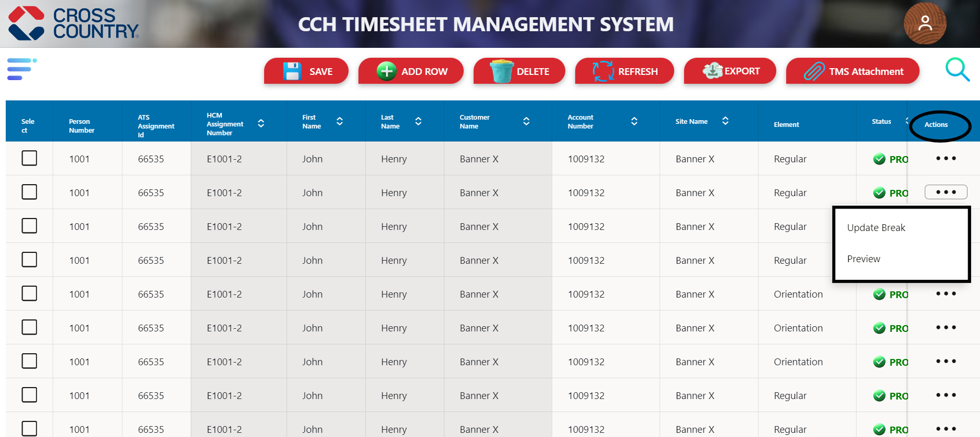

* Navigation: - In the action column of the respective row, click the three-dot icon to access the "**Update** **Break**" option for modifying meal breaks.

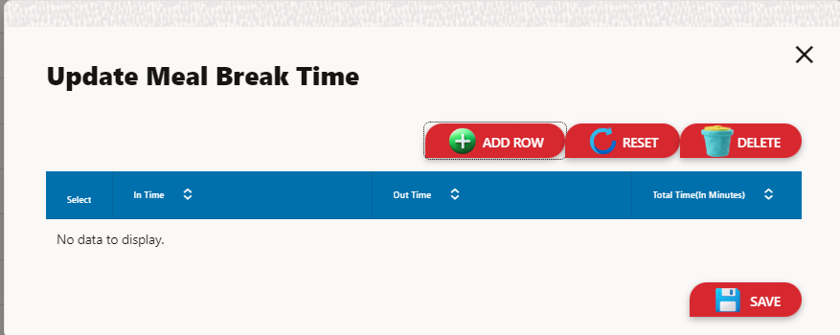

* After selecting "Update Break," the "**Update Meal Break Time**" window will be displayed, allowing you to manage break times with options to ADD ROW, RESET, or DELETE entries.
* The system will record the specified break time, subtract it from the total duration period, and update the displayed total time for the respective row accordingly.

* To update meal break time, Click the "**ADD Row**" button to insert a new row where you can specify the "From Time" and "To Time" for the meal break, then click the "**Save**" button.
* The system will reduce the total duration by the added meal break time and update the displayed total time for the respective row accordingly.

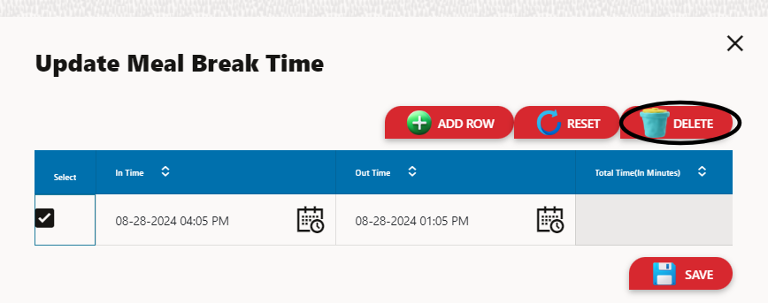

* Selecting a row and clicking the delete button will remove the row and automatically recalculate the time to reflect the change.

## 5.4 Timesheet Attachment

Below image is the main TMS screen: -

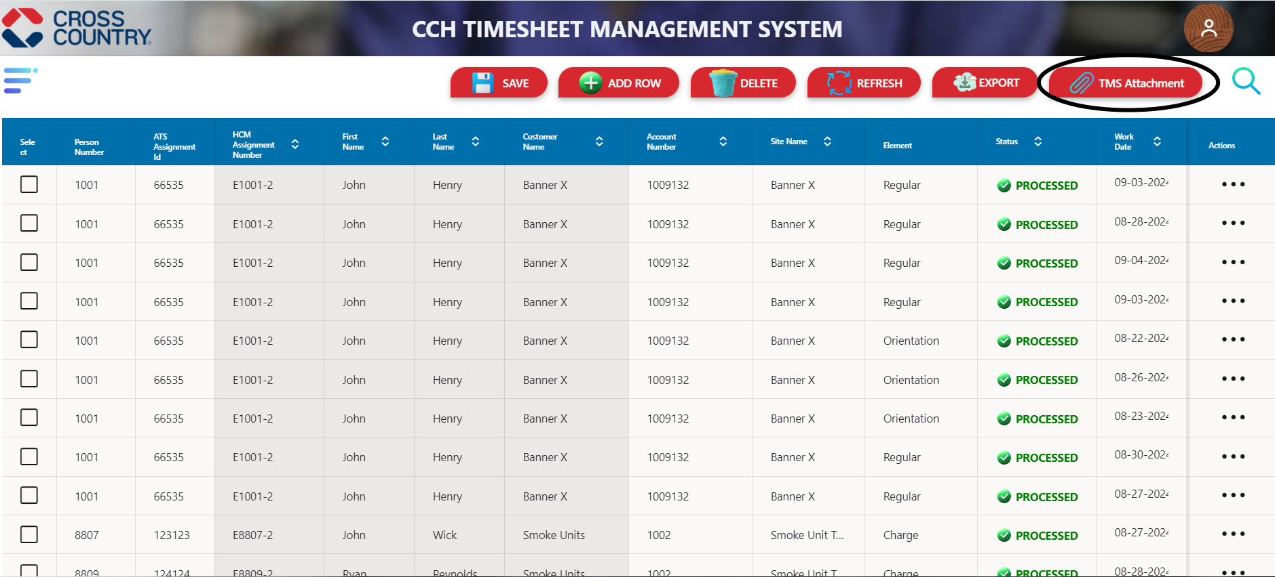

* **TMS Attachment** Functionality: On the TMS screen, the "TMS Attachment" button allows users to attach images to any row, utilizing this feature to associate files with specific data entries.
* **Storage and Preview**: The attached images are stored in object storage, which manages them in a structurally flat data environment. Once uploaded, the images are available for preview directly on the screen.

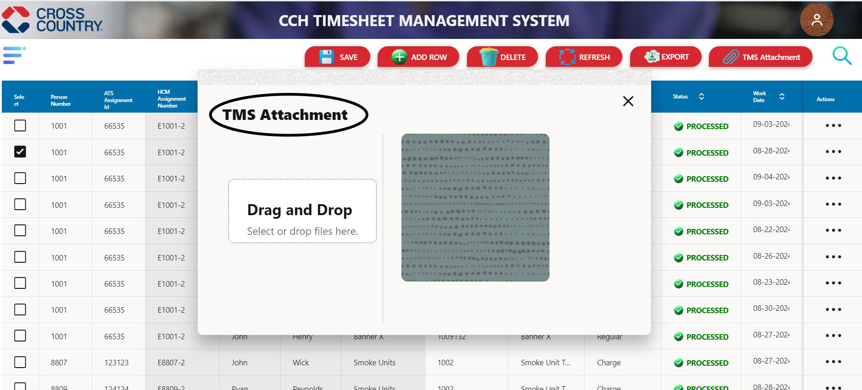

* **File Attachment Process**: To attach an image, first select the desired row, then click the "TMS Attachment" button to open a file upload screen.
* On the upload screen, users can select and upload the file of their choice by using “**Drag and Drop**” option and it will store into object storage, user can view the uploaded file directly within the interface.

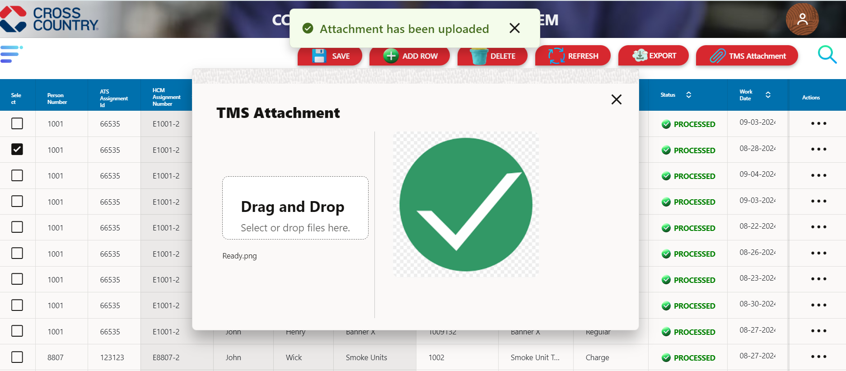

* Upon successful file upload, the system provides a notification stating "Attachment has been uploaded" to confirm the completion of the process.

* To preview the attached file, click the three-dot icon in the action column of the respective row and select "Preview." This action opens the TMS Attachment screen, where the previously uploaded file can be reviewed.

* The TMS Attachment screen will now display the file name along with a preview of the attached file, providing an overview of the uploaded content.

## 5.5 Time Entry Element

**TERP-3036** - Time Elements need to maintain TMS. Users can select Time Entry Elements from the drop-down list.

The image displayed represents the primary interface of the Timesheet Management System (**TMS).**

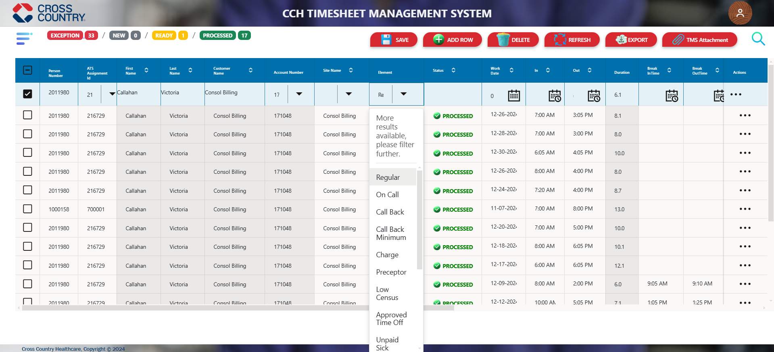

* The **Time Entry** feature enables users to choose their desired time entry option from a predefined dropdown list.
* The dropdown options are dynamically fetched from the **Lookup table** in the **ATP** database. This ensures users can access the latest and standardized data for accurate time entry selection.

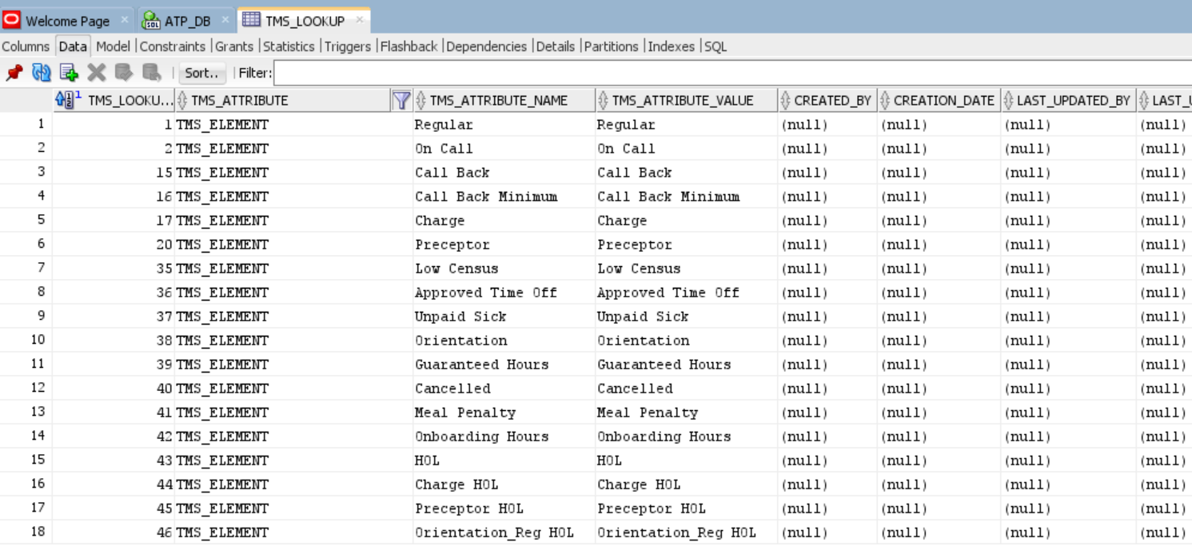

* The Lookup table from the ATP database is utilized to populate a dropdown menu on the VBCS screen in the TMS interface.
* This dropdown presents users with standardized options sourced directly from the database. By integrating this feature, the system ensures real-time data accuracy and consistency for time entry selection.

## 5.5 Technical components list

List of technical components to be developed for the custom object.

|  |  |
| --- | --- |
| **Technical Component Name** | **Description** |
| Table | Table to store employee time entry Information |
| Fields | To enter the data by field which want to search |
| Search Button | To search the data |
| Reset Button | To reset all values to default state |
| Save Button | To save the changes |
| Delete Button | To delete the row data |
| Add Row Button | To add the new row |
| Process1 | Process to load data from ATP to Oracle VBCS |

## 

## 5.6 References

The following references are related to this document.

|  |  |  |  |
| --- | --- | --- | --- |
| Document Name | Revision | Document Description | Document location URL |
| Project Titan-TDD-INT097_CCH_Timesheet_Management_Dashboard |  | Functional Design Document of CCH Timesheet Entry | https://crosscountry.sharepoint.com/:w:/r/sites/OracleCloudImplementation/Shared%20Documents/General/07-Build/Phase%202/HCM/FDDs/FDDs%20-%20OTL/Hourly%20Timesheet%20Management/Oracle%20ERP%20implementation%20FDD%20-%20CCH%20Timesheet%20Management%20System.docx?d=w1555922c370b424bb548cf63c0a7921c&csf=1&web=1&e=2Ow5E7 |
| Project Titan-TDD_CCH_TMS_Assignment_Package |  | PL/SQL | Project Titan-TDD_CCH_TMS_Assignment_Package.docx |
|  |  |  |  |
| TMS_MAIN Table |  | Database Table | tmsmain.sql |

# Open and Closed Issues

## Open Issues

| Issue ID | Description | Opened By | Responsible | Due Date |
| --- | --- | --- | --- | --- |
|  |  |  |  |  |
|  |  |  |  |  |
|  |  |  |  |  |
|  |  |  |  |  |
|  |  |  |  |  |

## Closed Issues

| Issue ID | Description | Resolution | Signoff | Closed Date |
| --- | --- | --- | --- | --- |
|  |  |  |  |  |

# Attachments

| Sr. No. | Attachment | Description/Comments |
| --- | --- | --- |
| 1 | Layout Snapshot | CCH Timesheet Layout Screenshots |
| 2 | Table structure | Table structure of all attributes |